**4. ReactJS-HOL**

1. Create a new react application using *create-react-app* tool with the name as “blogapp”
2. Open the application using VS Code
3. Create a new file named as **Post.js** in **src folder** with following properties

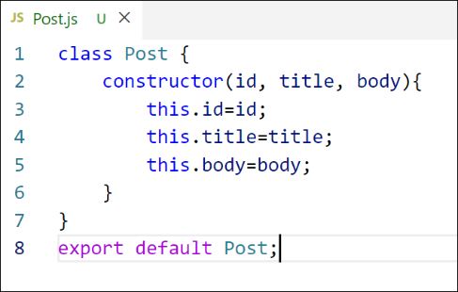

*Figure 2: Post class*

1. Create a new class based component named as **Posts** inside **Posts.js** file

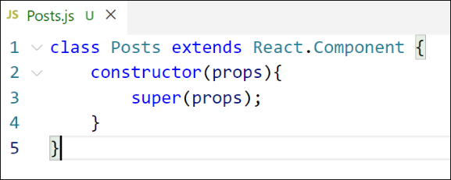

*Figure 3: Posts Component*

1. Initialize the component with a list of Post in state of the component using the constructor
2. Create a new method in component with the name as **loadPosts()** which will be responsible for using Fetch API and assign it to the component state created earlier. To get the posts use the url (<https://jsonplaceholder.typicode.com/posts>)

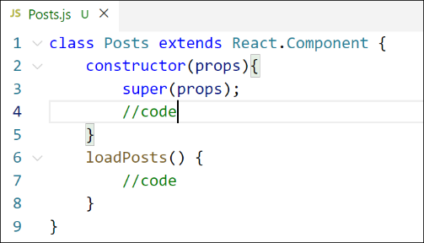

*Figure 4: loadPosts() method*

1. Implement the **componentDidMount()** hook to make calls to **loadPosts()** which will fetch the posts

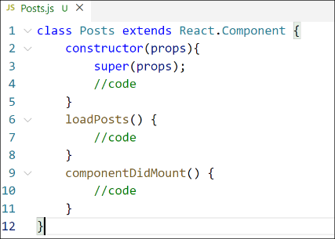

*Figure 5: componentDidMount() hook*

1. Implement the **render()** which will display the title and post of posts in html page using heading and paragraphs respectively.

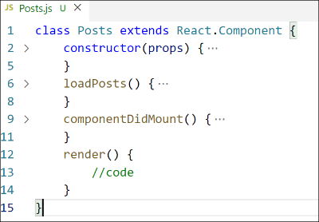

*Figure 6: render() method*

1. Define a **componentDidCatch()** method which will be responsible for displaying any error happing in the component as alert messages.

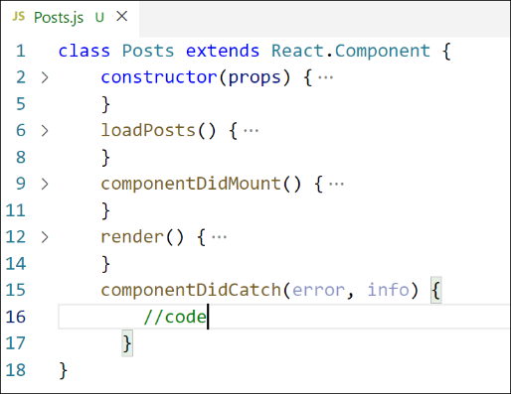

*Figure 7: componentDidCatch() hook*

1. Add the Posts component to App component.
2. Build and Run the application using *npm start* command.

**src/App.js**

import React from 'react';

import Posts from './Posts';

function App() {

return (

<div className="App">

<h1>All Blog Posts</h1>

<Posts />

</div>

);

}

export default App;

**src/Posts.js**

import React, { Component } from 'react';

class Posts extends Component {

constructor(props) {

super(props);

this.state = {

posts: [],

hasError: false

};

}

loadPosts = () => {

fetch('https://jsonplaceholder.typicode.com/posts')

.then(response => response.json())

.then(data => this.setState({ posts: data }))

.catch(error => {

console.error('Error fetching posts:', error);

this.setState({ hasError: true });

});

};

componentDidMount() {

this.loadPosts();

}

componentDidCatch(error, info) {

alert('Something went wrong in the Posts component.');

console.error(error, info);

}

render() {

const { posts, hasError } = this.state;

if (hasError) {

return <p>Error loading posts.</p>;

}

return (

<div>

{posts.map(post => (

<div key={post.id}>

<h3>{post.title}</h3>

<p>{post.body}</p>

<hr />

</div>

))}

</div>

);

}

}

export default Posts;

**index.js**

import React from 'react';

import ReactDOM from 'react-dom';

import './index.css';

import App from './App';

ReactDOM.render(<App />, document.getElementById('root'));

**Output:**

